New Information is in Blue Text
Event Name | Caldor Fire: 08242021-163
Date | 09/02/2021 1600
Report Number | 10
Duty Officer – 775-687-0498: Rodney Wright
Current Situation
Governor Sisolak has signed a Declaration of Emergency and the Douglas County Board of Commissioners has declared a State of Emergency in response to the Caldor Fire. As of 1345, the Caldor Fire has burned 210,259 acres and is 25% contained. Evacuation orders in areas of El Dorado County, California have resulted in road closures and shelters opening within Nevada. Evacuation orders have been issued to Douglas County residents from Upper Kingsbury (South), Upper Kingsbury (North), Central Kingsbury, Lower Kingsbury, Lake Village, and Lower Olivers (Kahle Drive region and roads). An evacuation warning has been issued for Mottsville. Casinos in the South Lake Tahoe area have begun closing some gaming operations, but the hotels and to-go restaurants remain open.
The evacuation order for the Round Hill region was rescinded. The order was issued out of an abundance of caution and is no longer considered necessary.
ESF 1: Transportation |  |  | Duty Officer: 775-888-7645
As of 1900, the following highway restrictions are in place to facilitate evacuations and limit access to affected areas:
- US-50 closed to westbound traffic at Spooner Junction (South Carson St. and US-50)
- SR-207 (Kingsbury Grade) closed to westbound traffic
- SR-28 Closed to southbound traffic from US-50 Junction

NDOT, in coordination with NVNG and NHP have implemented 7 traffic control plans to assist in the evacuation of the Lake Tahoe Basin.

As of 1400, Nothing new to report
ESF 4: Fire |  |  | Duty Officer: 775-684-2560
No Report at this time
ESF 6: Mass Care
As of 0730 on 9/1/21, the current shelter status is as follows:
- Douglas County Community Center has 1 evacuee. Due to cost effectiveness, the shelter may not stay open for the night and will hotel the resident.
- Carson City Community Center is closed
- Fuji Park is closed.
- Reno Sparks Convention Center opened at 2100 on 08/30/21 with room for 454.
- Dayton Event Center/Rodeo Grounds have room for 100-150 recreational vehicles for dry camping with a limited number of large animals.
- Lyon County Fairgrounds has room for 200 RVs for dry camping with the ability to house large animals.

Red Cross Managed Shelter Updates as of midnight on 09/01/2021:
Congregate Shelters
Total Congregate Shelters in NSS: 4 (no change) from yesterday.
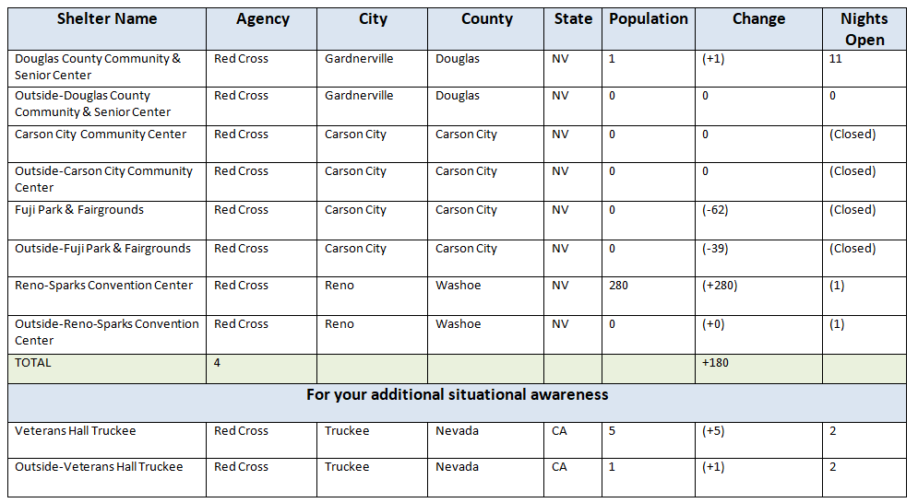

Red Cross continues to manage shelters to support residents affected by expanded evacuations around South Tahoe, CA. Red Cross is currently operating under the planning assumption that approx. 900 individuals would seek congregate sheltering in Nevada (3% of evacuated population). Three (3) additional shelters were opened yesterday, including Reno-Sparks Convention Center which opened late last evening and has a current COVID capacity of 454. On 9/1 this shelter will expand to a COVID capacity of 908. Red Cross has submitted a resource request to support this shelter with public health staffing, security and wrap around services (shower, toilet, hand wash stations).

In addition to all congregate (indoor) shelter sites, there are individuals residing outside on the premise (tent, trailer or RV) as reflected in the “Outside” count. This population receives wrap-around services but is not reflected in the congregate shelter count, per Red Cross standard operating procedures.

Mass Care Feeding
Meals Served: 3,099
Snacks Served: 1,108

Mass Care Distribution of Emergency Supplies (DES)
Comfort Kits Distributed in Shelters: 82
ESF 8: Public Health |  |  | Duty Officer: 775-684-5920
Providing COVID tests to shelters and licensure waivers to healthcare workers coming into the state. Carson Tahoe Health is requesting 25+ additional staff to assist with patient surge and staffing crisis. Continuing work with local reps and ESF 6 for the patient surge issue.
ESF 10: Hazmat |  | Rebecca Bodnar: 406-270-6000
Continuing to model critical infrastructure.
ESF 11: Agriculture |  | William Striejewske: 775-846-1165
No Report at this time
ESF 12: Energy |  |  | Lorayn Walser: 775-230-9851
Remain in contact with fuel suppliers and utilities. Fuel inventory is currently strong. Southwest Gas has begun the process of proactively turning off meters for safety reasons to previously isolated and evacuated areas in South Lake Tahoe, CA. Currently 541 customers presently without natural gas service. SW Gas will continue to follow the fire and may undertake additional meter shut offs depending on fire behavior and evacuations.
NV Energy continues to undertake proactive measures to prevent line and power loss. ESF 12, ESF 10, ESF 16, and NV Energy met to discuss transmission routing and potential power interruptions to infrastructure in Carson Valley."
ESF 13: Law Enforcement |  |  | Lt. Tony Roth: 775-720-8518
NDOT, in coordination with NVNG and NHP have implemented a traffic control plan to assist in the evacuation of the Lake Tahoe Basin.
ESF 15: Public Information |  |  | Gail Powell: 775-434-4795
Continuing to support Douglas County in taking media calls/inquiries and coordinating with California partners to coordinate messaging. Will be creating information packets.

Joint Information System has been activated and members have been given assignments. Coordination with CalOES, CalFire and county PIO’s on the California side. Questions for the JIC can be forwarded to 775-687-0395 or communicationrelationspio@gmail.com.
ESF 16: Nevada National Guard |  |  | JOC: 775-887-7200
55 NVNG members have been activated for response efforts. Members are assisting with door-to-door evacuation notifications.

